Shungnak Mini-grid Business Case

November 2017

MR Weimar

TD Hardy

Shungnak Mini-grid Business Case

MR Weimar TD Hardy

November 2017

Abstract

A business case analysis was performed for the Village of Shungnak for an islanded mini-grid. The business case analysis evaluated the optimal mini-grid configuration from the technical analysis performed by Sandia National Laboratory using Microgrid Design Toolkit (MDT). The optimal configuration adds a 500 kW wind plant, 100 kW of solar photovoltaics (PV), 100 kW diesel and 46 kW of electric thermal stoves. The project cost $4.3 million. The direct cost of electricity would likely decline from $0.63/kWh to $0.55/kWh. The direct costs don’t include administrative and distribution costs. The addition of the renewable resources reduced diesel fuel consumption by more than 74% or approximately 96,000 gallons. The reduction in cost provides an opportunity for Alaska Village Electric Cooperative to obtain financing through grants and loans to install renewable energy and reduce diesel fuel consumption to the cooperative.

Summary

As part of the Alaska Mini-grid Project (AMP), the National Renewable Energy Laboratory (NREL) conducted an analysis of potential renewable energy (RE) retrofit options for the Shungnak diesel mini-grid. Microgrid Design Toolkit (MDT), a mini-grid analysis tool developed by the Sandia National Laboratory, was used to evaluate options that maximized the net present value to the village and its utility. Those options were compared to the net present value of current diesel generation and the thermal load of the village. The options included combinations of solar, wind, hydro, batteries, and included electric thermal stoves to use renewable electricity that would otherwise be spilled. The assumed life of the project was chosen as 20 years as this was the lifetime of the most expensive asset, the wind turbines. The highest net present value alternative became the basis for the business case.

The highest net present value option added a 500 kW wind plant, 100 kW of solar photovoltaics (PV) and 46 kW of electric thermal stoves. The direct cost of electricity would be reduced from $0.632/kWh to $0.548/kWh[1] if provided by Alaska Village Electric Cooperative, the utility company, rather than an energy services company (ESCO). This assumes that the residents agree to have the electric thermal stoves installed and pay approximately $0.006 /kWh hour for their usage. If residents do not agree to the installation of electric thermal stoves (which is unlikely), the direct cost of the electricity would rise to $0.554/kWh. The installation of wind plant and solar PV reduces the amount of diesel fuel consumption from more than 129 thousand gallons per year to 33 thousand gallons, reducing diesel fuel consumption by 96 thousand gallons for Shungnak or a 74%. If residents don’t agree to the installation of the electric thermal stoves, approximately 0.414 million kWh of renewable energy would be unutilized. Residents could afford to pay up to $0.25/kWh for the electricity to power the electric thermal stoves and still break even on the cost of residential fuel oil.

The best case presented above was one of thirty-seven mini-grid configurations that were evaluated including the no-change base case. The options evaluated combinations of wind, solar, hydro and batteries with and without electric thermal stoves. Electric thermal stoves are used to convert any excess renewable energy to heat when electric demand otherwise would not consume all the renewable generation. Given the uncertain availability of excess wind energy, these stoves are expected to act as a low-cost supplemental heating source to the existing oil- or biomass-fired heating. Solar and wind generation was evaluated from 100 to 500 kW. Batteries were optimized based on the total system production and in some cases reached 100/100 kW/kWh. The analysis included hydro but hydro was never included in the least-cost set of mini-grid components because it was not cost effective.[2]

The diesel generation capacity at the village is currently 1298 kW provided by four diesel generators: a 202, 314, 365 and 397 kW. Each alternative generation option adds more renewable resources to the baseline, reducing the amount of diesel fuel and heating oil required to meet electricity and heating needs (respectively) up to the capacity of the village electricity demand.

The selected 500 kW wind system with solar PV, converters and electric thermal stoves costs $4.3 million installed. The cooperative utility is assumed to require a 4% rate of return on their investment, their weighted average cost of capital plus risk premium whether the capital comes from equity, grants and/or loans. Municipal and cooperative entities need to recover the cost of debt which could be the municipal bond market, bank for cooperatives, grants, or bank loans.

The primary risk associated with adding renewable energy to the village is failure to repay any loans incurred to finance the mini-grid upgrade. Based on a review of the options available, the project will need to find a grant for a portion of the capital costs and debt for the remaining costs as it appears that grants no longer fully fund projects. In addition, regardless of how the village chooses to fund the project (as part of the Alaska Village Electric Cooperative (AVEC), a limited liability company or a contract with an energy services company (ESCO)), the electricity price risk falls primarily upon the customers of the cooperative. They may face increased electricity rates should an unexpectedly large portion of the electricity be provided by the diesel generators instead of underperforming renewable generation. The increased diesel generation resulting from underperforming renewable generation will result in a higher variable cost of electricity. The PCE subsidy may ameliorate the risk as long as residential consumption doesn’t rise above 500 kWh per month for each residential customer.

An ESCO reflects returns for a for-profit entity and brackets the upper end of the return required. ESCO operators would require at least a 10% cost of capital. An ESCO would provide electricity as service to the cooperative rather than the cooperative managing the risk of the renewable generation. The optimal facility and capital requirements might be large enough to attract an outside entity. The price of electricity, given the 10% return hurdle rate by an ESCO, would require an approximate $0.68-$0.70/kWh, significantly above that of the local utility and above the direct costs of diesel generation at $0.63/kWh. In addition, there is some risk that the production tax credit (PTC) would expire by the time construction begins. The PTC for wind expires December 31, 2019. In addition, the PTC provides only 40% of the original $0.023/kWh, or $0.009 for 10 years for projects qualifying in 2019.[3]

Acknowledgments

The authors would like to thank Virginia Fay of University of Alaska Anchorage’s Institute of Social and Economic Research for her guidance and feedback in understanding the unique challenges of rural communities in Alaska.

Acronyms and Abbreviations

AMP – Alaska Mini-grid Project

CREBS – Clean Renewable Energy Bonds

Elec – Electricity

ESCO – Energy Services Company

EPC – Engineering, Procurement and Construction

FY – Fiscal year

Gal – Gallon

ITC – Investment Tax Credit

kW – kilowatt

kWh – kilowatt hour

MDT – Microgrid Design Toolkit

MW – megawatt

MWh – megawatt hour

NEPA – National Environmental Protection Act

O&M – Operations and maintenance

PTC – Production tax credit

PV – Photovoltaic

RE – Renewable Energy

REAP – Rural Energy for America Program

USDA – US Department of Agriculture

USDOE – US Department of Energy

Contents

Abstract iii

Summary v

Acknowledgments vii

Acronyms and Abbreviations ix

1.0 Introduction 1.1

2.0 Background 2.1

3.0 Project Objective 3.1

4.0 Project Description 4.1

5.0 Alternatives Studied 5.1

6.0 Permitting 6.1

7.0 Risks 7.1

7.1 Financial risks 7.1

7.2 Other issues associated with financing 7.3

8.0 Financial Analysis of Selected Option 8.1

Appendix A – Future Business Case Requirements Outline A.1

Figures

**Figure 2-1:** Regional map of Shungnak 2.2

**Figure 4-1:** Project schematic of the mini-grid retrofit to be implemented 4.1

Tables

**Table 2‑1:** PCE Statistics, 2012-2016 2.2

**Table 4‑1:** Resources and assumptions used in the analysis 4.2

**Table 4‑2:** Battery statistics by size 4.3

**Table 5‑1:** Annual heating and diesel fuel expenditures in the Baseline and Optimal cases* 5.1

**Table 8‑1:** Marginal price of village utility and ESCO options 8.3

**Table 8‑2:** Sources and uses of funds 8.1

**Table 8‑3:** Income statement of project 8.2

**Table 8‑4:** Cash flow statement for project based on 4% rate of internal return 8.3

# Introduction

As part of the Alaska Mini-grid Project (AMP), the Sandia National Laboratory conducted an analysis of potential renewable energy (RE) retrofit options for the Shungnak diesel mini-grid. This paper provides the business case for the optimal solution undertaken by the technical team reviewing potential options for Shungnak. The Microgrid Design Toolkit (MDT), a mini-grid analysis software package developed by the Sandia National Laboratory was used to evaluate options that maximized the net present value to the village and its utility. The options were compared to the net present value of current diesel generation and the thermal load of the village. The options evaluated included combinations of solar, wind, batteries, and electric thermal stoves to use renewable electricity that would otherwise be spilled. Electric thermal stoves convert excess renewable energy to residential heat when village electric demand is less than the renewable generation available. The highest net present value alternative became the basis for the business case analysis.

Shungnak currently has four diesel generators with 1,278 kW of capacity. Thus, a mini-grid design consisting of adding wind, solar, batteries, an additional small (100 kW) diesel generator, and thermal electric stoves was analyzed to reduce diesel fuel dependency. The highest net present value option adds a 500 kW wind plant with 100 kW of solar photovoltaics (PV), and 46 kW of electric thermal stoves and costs approximately $4.3 million.

# Background

Shungnak is a rural village located in Northwest Arctic Borough in Northwest Alaska with a population of 299 in the 2016 (Figure 2-1).[4] Currently, Shungnak obtains all of its electricity through diesel-fueled generators operated by the Alaska Village Electric Cooperative. Most of the 77 homes are not thoroughly insulated nor do they have energy-efficient appliances.

The village receives its electricity from four diesel generators with a total combined capacity is 1,278 kW. Current diesel electricity generation provides 1.6 MWh per year to the community, and is assumed to rise 0.75% per year through the analysis time period. Peak electric demand for the year occurs in January at just over 362 kW. Diesel consumption for 2016 increased to 121,883 gallons[5] from 2015 at an average price of $5.22/gallon[6]; 2014 was the high for 2012-2016 at 123,751. The price in 2012 was significantly higher at $7.51/gallon[7]. Residential housing is primarily heated by fuel oil. Low temperatures during the winter can reach as low as -24oC with averages in January of of -47oC.

Electricity prices to the community, based on PCE filings, appear to be priced using residential and commercial rates. The average rate, calculated across all kWh sold to all consumers, was $1.01/kWh in 2016. The State of Alaska Power Cost Equalization (PCE) program attempts to lower the price of electricity in rural areas of Alaska based on electric rates in Anchorage, Fairbanks and Juneau. The program primarily offsets the price of energy for the first 500 kWh of electricity used per month for residential customers. Residential electricity consumers receive a subsidy of $0.51/kWh cents. The rate charged to residential consumers was $0.73/kWh providing an effective rate of $0.23/kWh. AVEC reported nonfuel expenses at $0.28/kWh.[8]

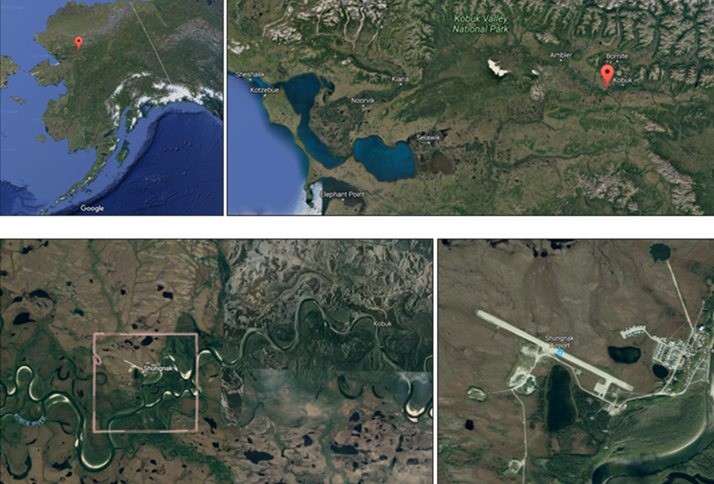

**Figure 2-1:** Regional map of Shungnak. Shungnak location in Alaska (upper left), location in Northwest Arctic Borough (top right), location on the Kobuk River (bottom left), and view of Shungnak Village (bottom right) Source: Google Maps

See Table 2-1 for diesel prices from FY2012-FY2016. The table also indicates the cost of electricity sold over the same period. In addition, note the high line losses shown from 2013 and 2016 at over 40%. Powerhouse consumption is about 2.8% of production.

**Table 2‑1:** PCE Statistics, 2012-2016[9]

|  |  |  |  |  |  |
| --- | --- | --- | --- | --- | --- |
| Year (Calendar) | FY2012 | FY2013 | FY2014 | FY2015 | FY2016 |
| Diesel cost ($/gal) | $7.51 | $5.10 | $6.84 | $5.36 | $5.22 |
| Diesel consumption (gal.) | 117,382 | 122,825 | 123,751 | 117,349 | 121,883 |
| Elec. cost ($/kWh) | $0.83 | $0.91 | $1.10 | $0.95 | $1.01 |
| Elec Generation (MWh) | 1,588,139 | 1,732,010 | $1,721,352 | 1,591,761 | 1,572,529 |
| Elec Consumption (MWh) | 1,520,182 | 980,235 | 971,754 | 900,015 | 879,140 |
| Line loss (%) | 1.7 | 40.7 | 40.7 | 40.3 | 41.2 |

# Project Objective

The Project retrofits the mini-grid for Shungnak composed of renewable energy resources including a mix of wind, batteries, and thermal stoves. The retrofit replaces electricity generated by existing diesel generators to reduce the dependence on expensive diesel-fuel generated electricity. Historically diesel prices have risen to as high as $7.51/gallon in 2012 and averaged $6.01 over the 2012-2016 time period. The analysis assumed a $7.16/gallon price for the diesel fuel for electricity generation and $7.99/gallon for home heating oil. The project expects to reduce diesel fuel demand for electricity by 74% from estimated baseline levels due to the construction and installation of the renewable generation. The battery bank and converter are sized to cover lulls in the wind during diesel-off operation.

The project will also reduce the demand for heating oil through the use of electric thermal stoves that use surplus renewable energy (energy generated by renewable resources that exceeds the demand for electricity). Thermal electric stoves bought by the utility and leased to customers with low-cost renewable electricity may provide a greater return to the utility on renewable energy that would otherwise be spilled. In addition, proposed energy efficiency projects for buildings will reduce the demand for electricity and fuel oil reducing overall demand for diesel and heating oil. The business case only provides an analysis of the mini-grid resources developed for the village and assumes that any energy efficiency improvements are realized and assumed to be completed prior to the beginning of the operation of the upgraded mini-grid. These upgrades provide a reduced thermal and electrical load on which the mini-grid operates over the project life, The technical project analysis evaluated renewable energy resources with and without the energy efficiency upgrades and the renewable energy and energy efficiency cases provided the highest net present value.[10] The project expects to reduce the cost of electricity and improve environmental conditions through the use of renewable resources instead of diesel generation.

The business case evaluated the feasibility of the cooperative utility retrofitting their mini-grid with the renewable resources in this plan. The cooperative utility has a multitude of incentives that can be used to improve the internal rate of return. In this analysis, the utility was assumed to obtain a grant for the equity portion and a loan from one of the funding agencies available to cooperative entities. The following programs may provide funding: Native Alaska corporations, the Power Project Loan Fund, Renewable Energy Grant Program, Clean Renewable Energy Bonds (CREBS), and the USDA – Rural Energy for America Program (REAP) Grants. The Renewable Energy Grant from the Alaska Energy Authority (AEA) currently has received no new funding and has a waiting list so it may not be a possibility. An additional source of funds could be Native corporations. In addition, there is a growing number of renewable energy projects financed for the production tax credits.[11] However, tax equity availability could shrink as the production tax credit expires. In addition, tribal corporations may qualify for the Tribal Energy Grant Program[12]. In addition, if investment requirements are met, Shungnak’s utility could potentially obtain financing through other alternatives such as the DOE loan guarantee program should they be able to meet the requirements of the program.

# Project Description

The retrofitted mini-grid proposed includes 500 kW of wind combined with a 100 kW solar PV and 46 kW of electric thermal stoves. The assumed life of the project was chosen as 20 years as this was the lifetime of the most expensive asset, the wind turbines. The total cost of the proposed installed project is $4.3 million, $3.4 million of which covers 5 wind turbines and converters. The project will also include the accompanying switchgears, controllers and software required to operate the mini-grid. The proposed option was the optimal configuration based on an analysis using the MDT analysis tool. The proposed option was selected from an array of options that included wind, solar, hydroelectricity, batteries and thermal stoves. The mini-grid installed will supplement and reduce diesel consumption used in current generation by 95 thousand gallons per year.

The installed costs, operating costs and assumed lifetimes for each of the resources are shown in Table 2. The installed costs reflect the harsh climate in Alaska as well as the remoteness of the community. No values for diesel generators were included; any existing generation in the village was assumed to be new and are treated as sunk costs. However, the diesel generators are assumed to last 60,000-100,000 hours and due to their low usage in the optimal solutions, they were not replaced during the 20-year project lifetime. The renewable resources are expected to have a 20 year life with the exception of hydro which has a lifetime of 30 years. The assumptions are based on the baseline values in MDT.

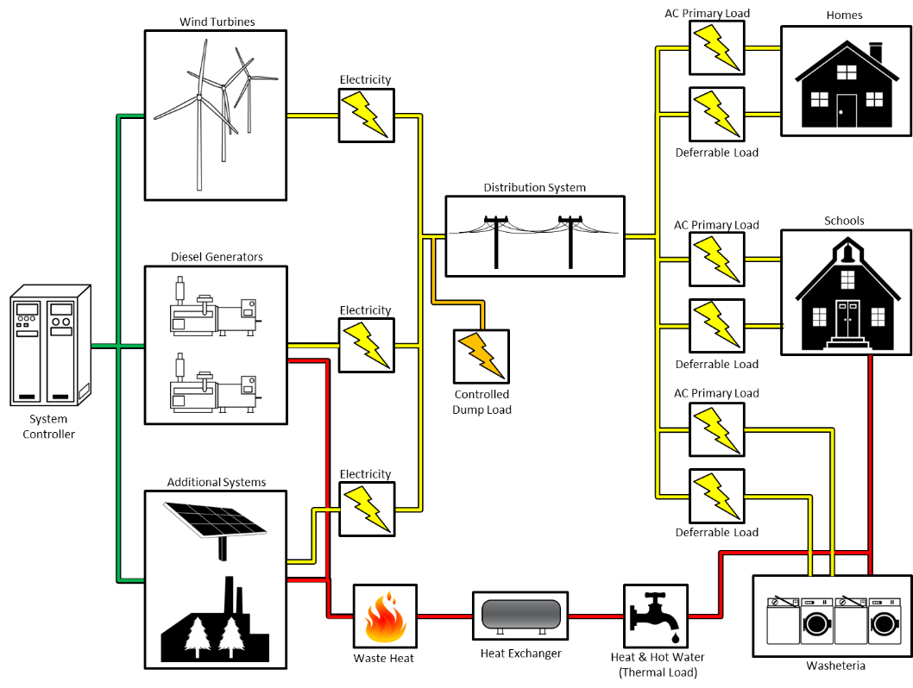

**Figure 4-1:** Project schematic of the mini-grid retrofit to be implemented

**Table 4‑1:** Resources and assumptions used in the analysis

|  |  |  |  |  |  |
| --- | --- | --- | --- | --- | --- |
| Wind Turbines (No. 100 kW) |  | 1 | 3 | 5 | 8 |
| Installed Capital Cost ($/Turbine) |  | 900,000 | 731,667 | 670,000 | 628,750 |
| O&M ($/kW) |  | 175 | 166 | 158 | 151 |
| Lifetime (years) |  | 20 | 20 | 20 | 20 |
| Solar PV kW |  | 100 | 300 | 500 | 800 |
| Installed Capital Cost ($/kW) |  | 5,000 | 5,000 | 5,000 | 5,000 |
| Solar PV O&M ($/kW) |  | 20 | 20 | 20 | 20 |
| Lifetime (years) |  | 20 | 20 | 20 | 20 |
| Batteries (kW) |  | 200 | 400 |  |  |
| Installed Capital Cost ($) |  | 190,000 | 382,000 |  |  |
| Battery Replacement Cost ($) |  | 142,000 | 178,500 |  |  |
| Batteries O&M ($/year) |  | 4,000 | 6,000 |  |  |
| Lifetime (Number of Cycles) |  | Number of years option dependent | | | |
| Converter capacity (kW) |  | 160 | 320 |  |  |  |  |  |  |
| Converter Installed Costs ($) |  | 190,000 | 382,000 |  |  |  |  |  |  |
| Replacement Costs ($) |  | 142,000 | 178,000 |  |  |  |  |  |  |
| O&M ($/year) |  | 1,600 | 2,400 |  |  |  |  |  |  |
| Lifetime (years) |  | 15 | 15 |  |  |  |  |  |  |
| Electric Thermal Stove Capacity (kW) |  | 100 | 300 | 600 | 900 |  |  |  |  |
| Installed Cost ($) |  | 60,000 | 160,000 | 310,000 | 460,000 |  |  |  |  |
| Hydroelectricity Plant Capacity (kW) |  | 235 |  |  |  |  |  |  |  |
| Hydro Installed Capital ($/kW) |  | 43,909 |  |  |  |  |  |  |  |
| Hydro O&M ($/kW) |  | 88 |  |  |  |  |  |  |  |
| Lifetime (years) |  | 30 |  |  |  |  |  |  |  |
| Diesel 202 kW O&M ($/hr) |  | 15.78 |  |  |  |  |  |  |  |
| Diesel 371 kW O&M ($/hr) |  | 16.45 |  |  |  |  |  |  |  |
| Diesel 371 kW O&M ($/hr) |  | 16.76 |  |  |  |  |  |  |  |
| Diesel 371 kW O&M ($/hr) |  | 17.14 |  |  |  |  |  |  |  |
| Average diesel fuel ($/kWh) |  | 0.5305 |  |  |  |  |  |  |  |

Fixed O&M costs for diesel generation are not avoidable while diesel fuel costs are avoidable. Note that some non-fuel O&M costs associated with the diesel are hourly, meaning that they are only incurred if the diesel generator is operating. Thus if diesel generation is to be maintained in the village, fixed O&M costs are required regardless of the extent to which the diesel operates. But hourly O&M and fuel charges change by the amount of time the diesel generation is operated. Similarly, O&M for renewables such as wind and solar are considered variable because they are still future costs and can’t be avoided. They are also dependent on run-time hours for wind.

The characteristics of the batteries used in the analysis are shown in Table 4-2. Note the largest size in the table is 100 kW / 100 kWh. The battery has a $50,000 integration cost and then is estimated to cost $700/kW for the first 200 kW and $480/kW over 200 kW installed. The replacement costs are slightly lower with an initial cost of $37,500 instead of 450,000. Converter upfront costs are similar. Replacement of the converter was assumed to occur at the end of year. Battery life is often specified in charge-discharge cycles rather years (assuming the battery is part of routine use).

**Table 4‑2:** Battery statistics by size

|  |  |  |  |
| --- | --- | --- | --- |
| **Item** | **Bat 100/100** | **Bat 50/50** | **Bat 10/10** |
| Cost | $150,000 | $100,000 | $60,000 |
| Operational Cost | $0 Dollars/Hour | $0 Dollars/Hour | $0 Dollars/Hour |
| Charging Efficiencies | 89.4% | 100% | 89% |
| Discharging Efficiencies | 89.4% | 100% | 89% |
| Energy Capacity | 100 kWh | 50 kWh | 10 kWh |
| Max Charge Rate | 100 kW | 50 kW | 10 kW |
| Max Discharge Rate | 100 kW | 50 kW | 10 kW |
| Min State of Charge | 10% | 10% | 10% |
| Max State of Charge | 90% | 90% | 90% |
| Desired State of Charge | 0.7 | 0.7 | 0.7 |

# Alternatives Studied

Thirty-seven options were evaluated using MDT[13] (see technical report); a base case (existing diesel-only configuration) was created in order to create a baseline against which the diesel fuel consumption in the prospective mini-grid configurations could be compared. Each alternative also included an option on whether electric thermal stoves could be used as an alternative load for otherwise unneeded renewable energy. Additionally, evaluations were made with and without the assumptions of energy efficiency upgrades being made prior to the operational period of the mini-grid. In all evaluated scenarios the energy efficiency upgrades were found to be cost effective and thus were assumed to be completed.

The renewable alternatives evaluated the level of wind, the kW of solar PV, and the total installed capacity of the electric thermal stoves that maximized the net present value. Alternatives for wind reached as high as 16 turbines. Battery capacity was evaluated between 0/0 kW/kWh and 100/100 kW/kWh, while thermal stoves were evaluated between 0 and 80 kW, or 14 electric thermal stoves. The number of electric thermal stoves that could be installed (assumed at 6 kW each) was limited by the estimated thermal load for the village. Hydro generation was considered, but wasn’t selected because it wasn’t cost effective.

The diesel generation capacity at the village is currently 1298 kW. The diesel generators use about 129 thousand gallons of fuel each year in the baseline analysis, or about 13.5 gallons per hour per generator. Each alternative generation option adds more renewable resources to the baseline, reducing the amount of diesel fuel and heating oil that are required to meet electricity and heating needs.

The option that provides the highest net present value to the village is a 500 kW wind facility, 100 kW solar PV with 46 kW of electric thermal stoves assuming a 4% discount rate. The 500 kW of wind turbines and 100 kW of solar generate 1.3 million kWh, 0.16 million kWh of which are used by the 46 kW of electric thermal stoves. This option reduces diesel fuel consumption by more than 74% and overall fuel consumption by 69% (Table 4). The 500 kW wind facility, 100 kW solar PV, 100 kW diesel and thermal stoves was selected for displaying the sources and uses, income statement and cash flow *pro forma* for the Alaska Village Electric Cooperative.

**Table 5‑1:** Annual heating and diesel fuel expenditures in the Baseline and Optimal cases*

|  |  |  |
| --- | --- | --- |
|  | Baseline Case | Optimal Case |
| Total $ | $1,380,000 | $437,000 |
| Heating fuel | $1,453,000 | $240,000 |
| Diesel fuel | $927,000 | $198,000 |

*Totals may not add due to rounding.

# Permitting

Federal permits may be required to assure that all the federal requirements have been met, if federal funding is required to install the wind turbines. In addition, the project will need to determine the state and local permits required to site wind, solar at the village. Alaska’s Department of Environmental Conservation, Department of Natural Resources, State Historic Preservation Office, Regulatory Commission and Department of Transportation and Public Facilities need to be contacted to determine what permits are required for the sites to be used for renewable energy.

In addition, Federal agencies such as the Bureau of Land Management, Environmental Protection Agency, Federal Aviation Administration, the US Army Corps of Engineers and the Bureau of Indian Affairs may be involved in the permitting process. These agencies will help address the permits required to address land use, land access, noise, navigable air space, subsistence and cultural impacts, biological resource impacts, visual impacts, wetland disturbance, water quality and public health and safety. The lists below are some of the permits that may be required but is not all inclusive.

Federal permits are dependent on whether the project is sited on federal land or contains some kind of federal involvement, i.e. a “federal nexus”. The National Environmental Protection Act (NEPA) requires compliance if the project is on federal land or has federal funds involved. Federal Special Use Permits and Rights of Way may be needed if the facility is on federal land or uses federal land to access the project. A permit may be needed for response to the Endangered Species Act. If the project imposes a hazard to air traffic, a hazard determination will need to be undertaken. Impacts to the Clean Water Act will require permits.

State permits will be required if the project impacts fish-bearing waterways, impact cultural, historic or archaeological sites. State permits may also be required if the project crosses state lands.

Local village authorities need to be consulted as well to meet local planning commissions and zoning issues. Local permits may include building codes, setbacks and zoning restrictions.[14]

Typical federal permits include:

* National Environmental Policy Act. The lead agency will depend on land jurisdiction and requires a review of the environmental impacts of proposed actions. The permit is needed if the project is on federal lands; there is a need to access a federally owned transmission line; or there is any funding from federal grants.
* Federal Special Use Permits and Right of Ways. The lead agency will vary depending the land jurisdiction. The permit is required when turbines are placed on federal land.
* Notice of Proposed Construction. The Federal Aviation Administration requires permits when structures are higher than 200 feet (~60 meters). Additionally, the permit is required when tower is within 20,000 feet of a public use airport with a 3,200-foot runway or is within line of sight of an air defense facility.
* Endangered Species Act. The US Fish and Wildlife service regulates activities where construction or turbine operation threatens endangered species.
* Bald and Golden Eagle Protection Act. The US Fish and Wildlife service regulates activities where construction or turbine operation threatens bald or golden eagles. Golden eagle nests may need to be moved.
* Migratory Bird Treaty. The US Fish and Wildlife service regulates activities where construction or turbine operation threatens migratory birds.
* National Historic Preservation Act. National Historic Preservation Act. The Advisory Council on History Preservation and the Tribal Historic Preservation have jurisdiction to review any impacts to historic and Tribal resources. Action required if the activity impacts tribal resources or the site contains property eligible or listed on the National Register of Historic Places
* Clean Water Act. The Environmental Protection Agency regulates impacts on waters of the United States when there is a potential for discharge due to construction of wind facilities. The US Army Corps of Engineer may be included if construction activity includes dredging or fill material into waterways or wetlands.

Typical state permits include:

* Fish and Essential Fish Habitat. Alaska Department of Fish and Game provides for mitigation measures if a wind turbine site impacts fish habitat. The permit is required if construction requires crossing a fish-bearing water.
* Cultural, Historic and Archeological Resource Consultation/Studies/Permits. The State Historic Preservation Office requires permits when a site is identified that could impact or alter cultural resources.
* Alaska Coastal Management Program. The Alaska Department of Natural Resources regulates sites that are within the Coastal Zone area which includes land up to 200 miles from the coast.
* Land Use, Easements and Right of Ways. The Alaska Department of Transportation regulates projects that have transmission or property on or along property managed by the department.
* Hazardous Materials Permit. Department of Transportation requires permits for hauling batteries due to their hazardous waste content.

# Risks

There are a number of risks faced by the Shungnak utility, AVEC. The risks include repayment, fuel price, human capital and operational, costs, regulatory, technical, contracting, interest rates and Federal incentives. Each of these risks may have more than one root cause. In addition, other considerations such as sinking funds, project size and collateral issues should be considered. The risks stated here need to be evaluated and included in the analysis when a complete risk analysis of the project is undertaken.

## Financial risks

Repayment risk. The primary risk associated with adding renewable energy to the Shungnak mini-grid is repayment risk. The leading cause of the repayment failure is lower than expected renewable generation. Wind generation may not follow historical patterns and less electricity could be generated. In addition, the harsher climate in Alaska may cause more downtime than occurs in milder climates. Both of these issues lead to more diesel-based energy generation and higher electricity costs. As a result, consumers may face increased electricity rates over those anticipated. The higher rates, in turn, may lead to more payment delinquency. Increasing costs could exacerbate the repayment risk. Due to the potential for higher than expected energy bills, financiers may evaluate this risk and ask for a working capital fund to make payments in case of a revenue shortfall. Even though working capital earns interest, it still increases the cost of the project as it is either funded from equity (which is higher cost) or from the operating loan, both of which have higher costs than the potential interest earned.

Fuel prices. If fuel prices are lower than expected, less savings would occur and the energy from the installed renewable generation could be more costly than diesel fuel-driven electricity from a full-cost perspective. However, if the project is already in place, lower than expected fuel prices would decrease the cost of electricity, because once the equipment is installed most of the costs are fixed and only a relatively small renewable O&M cost is required. Higher future oil prices would provide even more savings and make the ESCO option profitable. Renewable energy will likely still be less expensive from a variable cost perspective.

Human capital risk. Human capital risk is higher in remote villages where the access to labor with the correct skills to operate and maintain a mini-grid may be more limited than in larger urban areas. The opportunity cost to individuals with the skills required to manage, operate and maintain a mini-grid may be higher than remote villages can afford. The individuals need product knowledge of the mini-grid equipment as well as an understanding of the proposed renewable energy systems. They will need knowledge and understanding of the electrical systems including batteries and the capability to manage a more complex distribution system and managing administrative and business management issues. The village may need to use a cooperative or ESCO approach if they don’t believe they have the expertise to operate the wind facility. An ESCO may be an alternative, as well, if a cooperative won’t undertake the project. However, the ESCO costs are estimated to be greater than the fuel costs of the current facility which would mean that electricity costs could rise to ensure that the ESCO’s required rate of return or hurdle rate is met.

Cost Risk. Cost risks have the potential to reduce operating income. Unexpected increases in the costs of labor, materials and supplies in conjunction with projects that have a limited ability to raise prices and thus revenue, can adversely affect operating income. For an ESCO, changing tax rates can also provide a source of cost risk to the project, although it is only lowering the after-tax return rate. The project should remain financially feasible.

Regulatory risk. Financiers will want to see regulatory risk well-defined and the process well-established for obtaining all permits required to begin construction. Without a well-established permitting process and with the time to completion of permitting unknown, financing will need to be from alternative sources such as grants and/or village equity. They will also evaluate the impact of potential changes in regulations and whether they could adversely impact permitting time and designs and in turn the construction costs. Thus, having the project well defined and the permitting, design and construction period confined to a defined period will reduce regulatory risk. Drawn out processes increase the potential for regulatory change, which increases costs.

Technical risk. Financiers are also going to look at technical risk as it impacts the revenues and costs. Construction schedule slippage increases the costs of construction through both direct, overhead and interest costs. Added costs lead to a higher total loan costs during operations. In addition, poor quality construction cost estimates may lead to much higher construction costs. Financiers also review the maturity of the technology being implemented to assure that equipment operates as designed. Failures that reduce capacity factors impact revenue. In the case of the systems designed for the Shungnak utility, the systems are assumed to be mature even though the system analyzed has only been demonstrated. The risk is whether the technology will operate as expected in Alaska winters. Financiers will also evaluate whether any fixes they believe are necessary to make the system work as expected in Alaska’s harsh winters may make the project financially infeasible. They will also investigate whether the operating parameters associated with O&M are well understood and the range of potential costs do not impact project debt coverage ratios.

Engineering, Procurement and Construction (EPC) risk. Financiers will also look at the EPC contracts to make sure that contracting risk is acceptable. They will look to see whether the dispute resolution process is defined and provides for cost-effective changes. The financiers will also evaluate default consequences for both the cooperative and the contractor and assure themselves the financial institution is not at risk. They will also assure themselves that if the project terminates that their losses are acceptable and minimized.

Interest rate risk. The project could face interest rate risk in the short and long term should the project be attractive to financiers. Construction interest rates may change during the design and permitting period. That could make the project less attractive. In addition, as the project goes forward, interest rates could rise during the construction period making the interest rates for the operating period less attractive. Lastly, as the project moves forward, the riskiness of the project could grow, increasing the spread between the index and the debt rate.

Federal and state incentives risks. Renewable incentives associated with most types of renewables have already expired. The renewable energy federal production tax credit (PTC) provides a tax credit (adjusted for inflation) per kWh of electricity produced. The wind PTC expires at the end of 2019. In 2017, the credit is $0.0184/kWh. The credit declines 40% in 2018, and 60% in 2019 from the 2016 base of $0.023. The PTC for all other technologies expired in 2016.[15] A 30% federal ITC is available for solar PV and thermal projects through 2019, after which there is a phased reduction in value of the credit until 2022 when the credit becomes 10% permanently.[16] The ITC is 26% in 2020 and 22% in 2021 (26 USC § 48(a)(6)). In addition, state incentives are not always completely funded. There is some risk the Alaska Energy Authorities Power Cost Equalization program may reduce incentives or that the Alaska legislature will not fully fund all of the incentive programs.

## Other issues associated with financing

Sinking funds. Once financing alternatives are investigated, the village may need to get grants to provide the upfront equity which will allow the financiers to see a minimum debt coverage ratio of 1.25. If there appears to be inadequate coverage for unusual events, the financier will probably require sinking funds to be set up to prepare for those shortfalls. The sinking funds may be associated with the capacity factor risk and other revenue shortfall risks such as rising fuel prices, capital replacement and major O&M repairs. Revenue risk may arise due wind speed variability, insolation variability, system downtime, equipment failure, and the time require to repair equipment in remote locations.

Project size. Another issue that may detract from ESCO participation is the project size. The project is somewhat small with the proposed mini-grid providing 600 kW of renewables. Additionally, total investment is not significant at $4.3 million. The project may not provide adequate cash flow to provide an appetite for investment by an ESCO. In addition, ESCOs usually like to see short payback periods. If the project can payback in 7 years or less, investors are more inclined to participate. The project at a 10% rate of return pays back in 7-8 years.

Collateral issues. There may also be issues with what is considered acceptable collateral from the community. Renewable energy projects have little value if they are in remote areas and the power can’t be exported and sold elsewhere. Additionally, the financier will want to see that the mortgagee has acceptable bookkeeping and billing systems to assure that repayment is made. In addition, communities may be forced to look for lenders of last resort because the remoteness and the amount of investment required may be too small to attract major lenders.

# Financial Analysis of Selected Option

The project costs $4.3 million installed. The project *pro forma* assumes a weighted average cost of capital approach to the cost financing as the financing approach at this time is unknown. Shungnak’s Alaska Village Electric Cooperative as a nonprofit cooperative utility would likely require a nominal 4% rate of return as the cost of their capital if borrowed could be as high as 3% and inflation is assumed to add another 1% to the required rate of return.

An energy service company (ESCO) could provide an alternative approach that provides delivery of electricity services for a rate of return above that which the Alaska Village Electric Cooperative might require. As such the cost of electricity may rise but the renewable energy resources may be more likely to remain viable. The ESCO would require a cost of capital in the 6.8%-10% range after tax at least. We evaluated the ESCO at a 10% internal rate of return. The ESCO would have to pay Federal, state and/or local taxes depending on their location. (There could be tax implications based on the ownership of projects on tribal lands and should be investigated.) Complete equity financing is expensive so debt would probably be included. Thus, between a not-for-profit and an ESCO we have bracketed the relative electricity costs.

Bank financing is usually short term and based on points above the London Interbank Offered Rate (LIBOR). The 12-month LIBOR rate ranged between 2.7 and 3.0 over the last six months.[17] In addition, renewables projects have been financed with tax equity. Typical renewable energy developers don’t have an appetite to reduce taxes so they partner with companies that do pay taxes and wish to reduce them. The tax equity usually requires 7.5-9.5% return on equity after taxes.[18] They usually require $75-$100 million in projects, so the ESCO would need more projects than an Alaska village to reach the tax equity appetite. The ESCO could also finance the projects based on its balance sheet which obtains debt secured by its assets. Corporate bond rates ranged as follows over the last five months: 10 year BBB+ bonds 3.79 to 4.02% and AAA 2.77 - 3.04%. Thirty year BBB+ bonds yielded between 4.9 and 5.24% over the last five months.[19] Thirty year US treasury rates are around 2.7-3.0% during May – October 2017. Institutional debt would be based on risk of the project above the treasury rate.

Municipal and cooperative entities need to recover the cost of debt, which could be the municipal bond market, bank for cooperatives, grants, or bank loans. The municipal market is based on the credit worthiness of the institution borrowing money. Currently 30-year, AA municipal debt is near 3.88% while B- is near 5.03%.[20] Twenty-year debt is somewhat lower.

Small villages are unlikely to have a bond rating to provide a basis for repayment risk. They may be able to receive grants and government subsidized loans to add to their infrastructure to reduce diesel oil consumption. The following provides a short discussion of alternatives: Power Project Loan Fund, Renewable Energy Grant Program Clean Renewable Energy Bonds (CREBS); and USDA – Rural Energy for America Program (REAP) Grants.

Power Project Loan Fund. The Alaska Industrial Development and Export Authority provides loans for renewable energy projects to local government, and municipal and cooperative utilities up to $5 million. Projects over $5 million require legislative approval. The interest rate varies but the highest rate is tied to municipal bond rates and maturity is set to useful project life. The power project loan fund can be a lender of last resort.[21]

Renewable Energy Grant Program. Upon state appropriation, renewable energy projects can receive grants to cover their costs. The legislature didn’t appropriate funds for projects in 2016, so projects are being held over for funding on the next round. Projects are funded directly by the legislature depending on public benefit. The funding can be obtained by investor-owned, municipal, or cooperative utilities, state or local government, utilities, tribal government, and retail suppliers.[22]

Clean Renewable Energy Bonds (CREBS). CREBS can be issued by Tribal, local and state governments, and cooperatives to fund renewable energy projects. The bondholder receives federal tax credits to cover the interest cost while the issuer must pay the principal portion, thus an interest free loan from the issuer’s perspective.[23]

USDA – Rural Energy for America Program (REAP) Grants. REAP grants are provided for installing renewable energy systems. The grants and loans are provided to commercial and agricultural producers and to entities that USDA chooses to fund. Grants can be up to 25% of project cost including design, permitting and construction. The remaining funds are provided in the form of a loan. Loan guarantees can’t exceed $25 million.[24]

Some combination of the above funding sources might be used to meet the project funding requirements. In addition, the project may benefit from tax incentives if the utility pays federal, state or local taxes. Alaska provides for property tax exemptions for renewable energy systems. The federal government provides an investment tax credit (ITC) for solar which remains at 30% through 2019 and then declines to 10% by 2022. Geothermal receives a 10% ITC. Large wind receives an 18% ITC in 2018 and 12% in 2019 and none thereafter. Small wind receives no credit. Large wind is greater than 100 kW.[25] Large wind can receives a $0.0184/kWh production tax credit in 2017. The credit is reduced by 40% in 2018 and 60% in 2019 from the 2016 level of $0.023/kWh and discontinued thereafter.[26] The federal tax credits, however can only be used by entities that pay federal taxes.

The sources and uses of funds sheet shows that $4.3 million of funding is required from a mix of sources listed above. The marginal cost of electricity is $0.632/kWh for diesel generation only with fuel providing $0.530/kWh of the total. A price of $0.681/kWh will be required for an ESCO to breakeven to reach a 10% return after taxes without the production tax credit and $0.673/kWh with the tax credit assuming construction begins by December 31, 2019. Prices for electricity supplied to the stoves would need to be approximately $0.006/kWh to recover the extra cost of the electric thermal stoves all consumers unexpectedly chose to opt-out of using the stovesThey make economic sense, so consumers probably will accept them. In the ESCO/ Cooperative approach, the ESCO was assumed to acquire the diesels free of charge.

The Alaska Village Electric Cooperative would need to repay the funding over the 20-year project life. Debt coverage ratios should never be lower than 1.25, a lender minimum. The utility would need to charge $0.548/kWh should they decide to operate the facility. The prices would be $0.550/kWh if no one chooses to use the electric thermal stoves. The remaining differences between projected prices and the prices listed here are distribution costs and overhead or General and Administrative (G&A) costs (see Table 8-1).

**Table 8‑1:** Marginal price of village utility and ESCO options

|  |  |  |
| --- | --- | --- |
| Alternatives | Shungnak Utility | ESCO |
| Direct Electricity Price with Thermal Stoves used | $0.548/kWh | $0.695/kWh |
| Direct Electricity Price with Thermal Stoves not used | $0.550/kWh | $0.697/kWh |

The two different prices for the utility provide a price range for the utility because of the uncertainty associated with consumer acceptance of electric thermal stoves. The thermal stoves breakeven for the consumer if the costs charged to them by the utility for electricity for the stoves is less than $0.20/kWh. In this case, consumers could be charged $0.006/kWh, which reflects the reduction the annualized cost per kWh of the electric thermal stove. The two different prices for each entity provide the range for the cost to the utility of the extra wind capacity should consumers opt 100% to lease stoves and 100% opt not to lease the stoves. The thermal stoves electricity cost less than the consumers use of heating oil, thus the use of the thermal stoves is cost effective. However, to the extent that customers are unwilling to use the thermal stoves, the cost of electricity to the village will need to rise to cover the extra renewable energy generation capacity installed only for the use of the thermal stoves.

The primary non-financial benefits to the community would be reduced diesel fuel consumption which would reduce particulate pollution and improve air quality. The particulate matter includes ash, carbon, metallic abrasion particles, sulfates and silicates. The effects of particulate matter exposure include dizziness, headache, and irritation of the eye, nose and throat. Long-term exposure increases the risk of cardiovascular, cardiopulmonary, lung cancer, and respiratory problem.[27] An additional benefit is that it reduces the risk of rising electricity prices as diesel fuel prices rise because the village is no longer so directly dependent on diesel fuel for electricity and home heating.

The Sources and Uses of Funds (Table 8-2) evaluates the installed cost of capital and the costs of alternative sources of funding. The statement of earnings in Table 8-3 for the Shungnak utility indicates that operating earnings provide adequate earnings at a 4% weighted average cost of capital to recover the facility costs over time. The cash flow statement (Table 8-4) provides the basis for the internal rate of return calculation.

**Table 8‑2:** Sources and uses of funds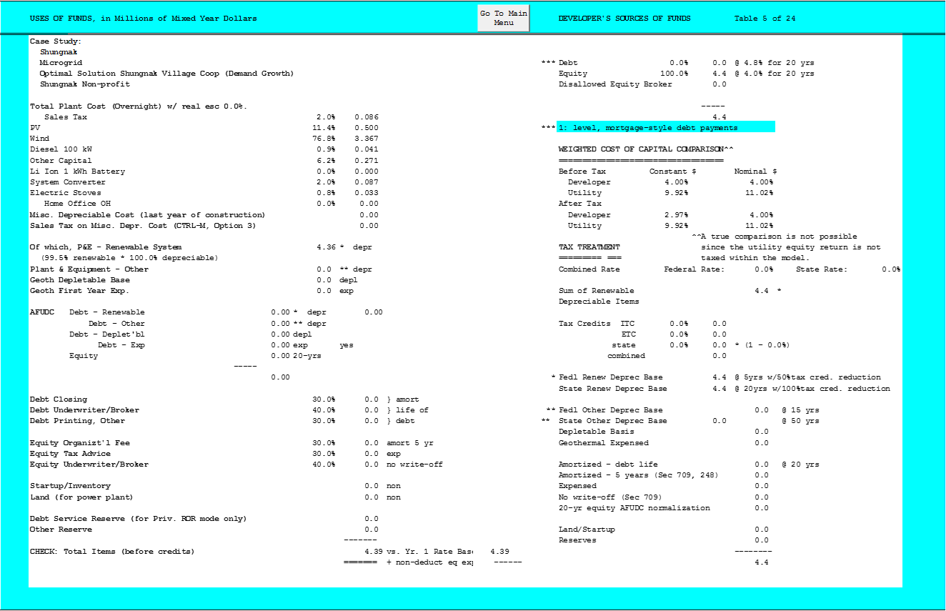

**Table 8‑3:** Income statement of project

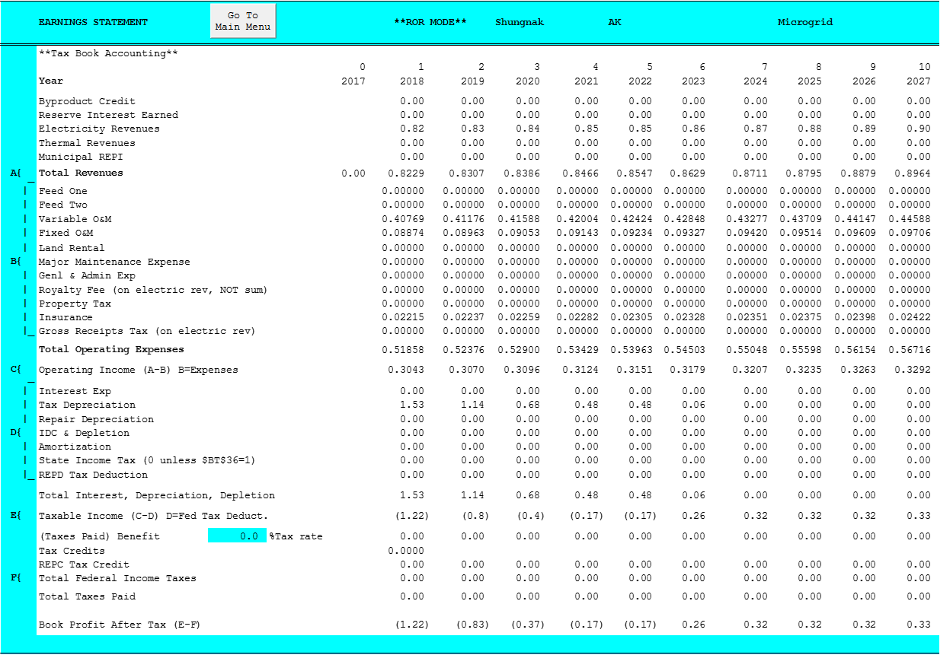

**Table 8-3:** Income statement of project (cont’d)

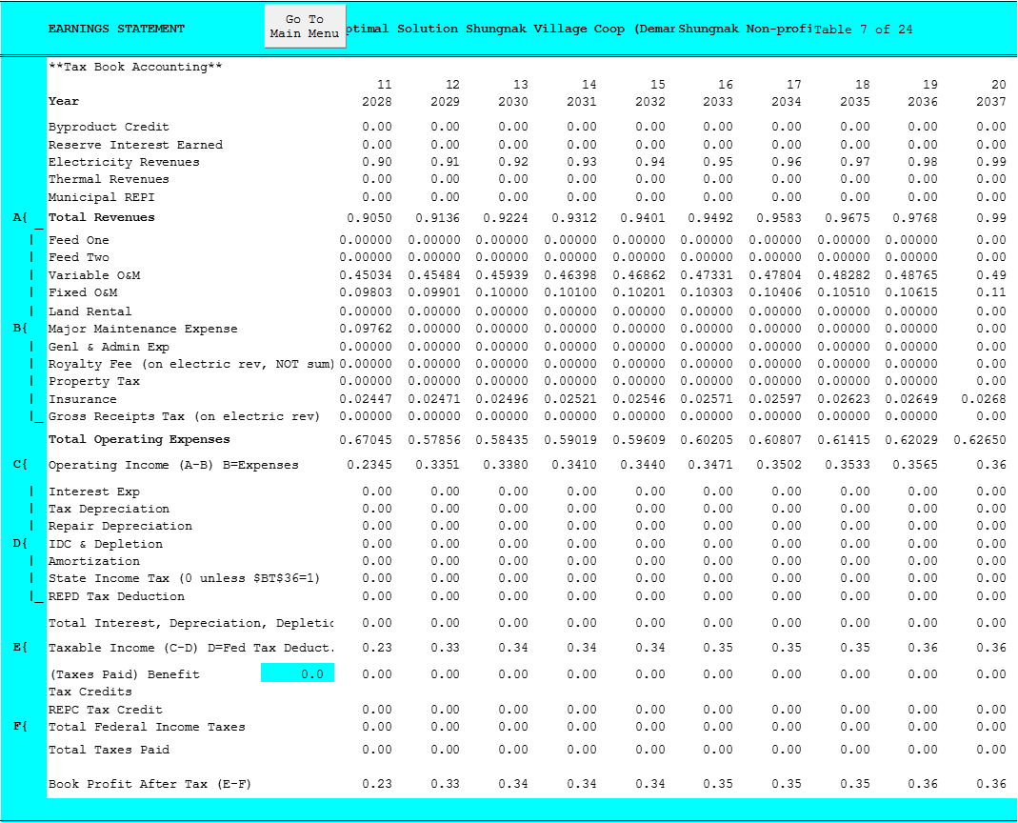**Table 8‑4:** Cash flow statement for project based on 4% rate of internal return

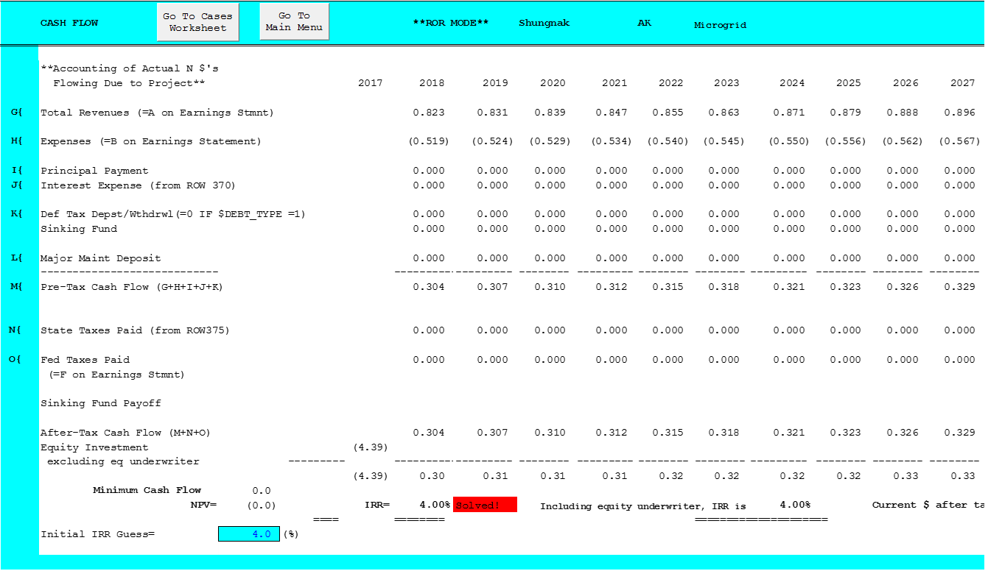

**Table 8-4:** Cash flow statement for project based on 4% rate of internal return (cont’d)



###### – Future Business Case Requirements Outline

*The appendix includes an outline of the information that will be required to evaluate a detailed business case for an actual financing. The most relevant information will include more in-depth estimates of the costs based on the technical analysis of the project reported in the Shungnak Mini-grid Configuration Options[28]. In addition, a more detailed description of the financial analysis will need to be undertaken as more detail gets put together before financing, but after the technical and permitting details are worked out. A more extensive exposition of the risks is involved. The following provides a detailed list of the items that may be required.*

**Technical**

There are several approaches to providing the detail to the business case above. Best practice would be to provide the complete set of alternatives in detail and describe the approach to determining the optimal combination of components. In addition, a detailed description of the components and how the costs were developed for each is delineated. In this case we refer you to the technical analysis of the Shungnak project.

* Methodological Approach
* Alternative 1
  + Mini-grid components
  + Schedule with enough detail to describe alternative
  + Costs
  + Benefits
  + Sensitivity analysis
* .....
* Alternative X
* Technical Details of Mini-grid
* Technical Details of Wind installation
  + Technologies analyzed and rationale for selected technology
    - Turbine size,
  + Wind speeds
    - Capacity factors
    - Variability
  + Construction schedule
  + Permitting issues
  + Impact of location on costs
  + Impact of extreme cold on costs
  + Etc
* Technical Details of PV installation
  + Technologies analyzed and rationale for selected technology
    - Installation size,
  + Insolation
    - Capacity factors
    - Variability
  + Construction schedule
  + Permitting issues
  + Impact of location on costs
  + Impact of extreme cold on costs
  + Etc
* Technical Details of Battery installation
  + Technologies analyzed and rationale for selected technology
    - Installation size, kW and kWh
  + Round trip efficiency
  + Impact of location on costs
  + Impact of extreme cold on costs
  + Etc
* Integration components and details
  + Technologies analyzed and rationale for selected technologies for each component
  + Impact of location on costs
  + Impact of extreme cold n costs
  + Etc

**Permitting**

The section should include all the permits that need to be obtained and the steps, time and cost required to obtain the permits:

* Building permits
* Environmental permits
* Other

**Financial**

The financial section should include the detailed information that was used to analyze the financial aspects of each alternative and the types of financing analyzed. The section should include the assumptions used to analyze each of the alternatives and there sources. The approach should be discussed including a discussion of the pro forma used to analyze the alternatives. A spreadsheet model would accompany the written documentation to illustrate the quantitative metrics of each alternative considered. The list includes:

* Installed costs ($/kW, $/kWh) of alternatives by component system costs
  + Wind
  + Solar
  + Battery
  + Balance of System for each alternative
* Length of construction period
* Capacity factors
  + Wind
  + Solar
  + Diesel generator
  + Round trip efficiency for battery
* Operating costs of each alternative
  + Variable Operations & Maintenance (O&M) costs by component
    - Fuel
    - Non-fuel O&M
  + Fixed O&M
  + Escalation rates expected
* Major maintenance costs including expected year of inclusion
* Depreciation schedules
  + For each component
* Tax rates
  + Income tax rates
    - Federal, State, Local
  + Gross receipts tax?
  + Sales tax rates
  + Property tax rates
* Insurance rates (make sure not to double count if included in the O&M costs)
* Incentives
  + Federal, State, Local
    - Investment tax credits, production tax credits
      * Rates by year of construction beginning
* Prices
  + Diesel prices, expected, potential variance
  + Any other value discovered during analysis
  + Escalation rates for each
* Expected hurdle rates required by alternative
  + ESCO rate
  + Village utility rate
  + Other alternative
* Financing Assumptions
  + Alternatives Studied
    - Debt financing fees
    - Interest rates during construction
    - Interest rates during project life
    - Debt/Equity percentages
    - Type of financing
      * Bank, bonds, grants,
        + Repayment function – mortgage style, other
    - Length of financing

**Risks**

The major risks should be summarized. Risks that apply to all cases can be summarized separately. The section should summarize the risk and the mitigation approach that has been developed. Private finance organizations will develop a list of risks and indicate who owns them if private finance is involved. Below is an extensive but not all-inclusive lists of risks. The results of the risk analysis should be summarized in this section and the complete analysis placed in an appendix.

* Financing Risk
  + Project feasibility risk
    - Adequate internal rate of return to entice investors
    - Debt service coverage ratios adequate for financing
    - Adequate collateral for cash flow shortfalls
  + Payback risk
    - Institutional capacity risk or ability to repay debt
      * Community’s ability to raise prices
        + to meet fuel price changes
        + to meet declines in demand

Historic load profiles are needed

* + - * Lack of timely utility customer payments
    - Project scale sufficient to meet payback requirements
      * Long payback periods may not be acceptable especially for bank financing
  + Acceptable collateral needs to be identified for community loans
    - Note: (Community utility assets may have little value in an isolated community with few alternative uses.)
  + Acceptable bookkeeping and records need to be made available to provide background on ability to repay
  + Availability of financing
    - Project of adequate size to attract pay for performance contractors
    - Interest rate risk
      * Overall interest rate movements
      * Spread between selected index and the debt rate
      * Variability enough to make project infeasible
    - Cost of debt placement still allows project feasibility
* Community’s human capital risk
  + Probability of utility employee turnover can be a barrier
  + Capable of managing complex distribution systems
  + Capable of managing administrative and business management requirements
* Incentive risks
  + Federal incentives declining and eliminated in the near term
  + Alaska Energy Authorities Power Cost Equalization program may reduce incentives
* Revenue risk associated: with
  + wind speed variability
  + insolation variability
  + system downtime
  + equipment failure
    - Time to repair acceptable?
* Technical risk
  + Impact of construction schedule slippage
  + Impact of construction cost overruns
  + Failure of system to work as designed
  + Fixes necessary make project infeasible?
  + Are O&M requirements understood and a maintenance plan in place?
* Cost risk
  + Unexpected cost escalation
    - Labor
    - Materials
    - Supplies
  + Higher operating costs than expected
    - Remote location risk
      * Added costs and range of costs
  + Change in tax rates
* Regulatory risk
  + Permitting risk
    - What permits are required
    - Issues in getting permits
    - Time to completion fixed or open-ended
  + Change in law or regulation risk
* Schedule risk
  + Impact of federal tax incentives to slipping construction start dates
  + Potential cost risk of slipping schedules
* Impact cold weather on operations and costs
* Contracting risk (if third party constructs or constructs and operates)
  + Dispute resolution defined?
  + Community default consequences?
  + Contractor default consequences?
* Termination provisions defined?

­­

Address Line 1

Address Line 2

City, ST Zip

Phone Number

1. The direct costs of electricity don’t include any administrative or distribution costs. They contain only the costs of the fuel, O&M, and initial capital and replacement costs. Thus the costs discussed should be considered as relative costs.
2. DM Rosewater, JP Eddy. November 2017. “Shungnak Energy Configuration Options: Energy Infrastructure Optimization to Reduce Fuel Cost and Dependence in Shungnak, Alaska. Sandia National Laboratories. SAND2017-11777R.
3. DSIRE. 2016. “Renewable Electricity Production Tax Credit (PTC).” Last updated May 24, 2016. Accessed August 24, 2017 at http://programs.dsireusa.org/system/program/detail/734
4. State of Alaska Department of Department of Labor and Workforce development, Accessed October 4, 2017 at http://live.laborstats.alaska.gov/pop/index.cfm
5. Alaska Energy Authority; Remote Alaska Communities Energy Efficiency Competition: Phase II Summary and Strategic Energy Efficiency Plan – Shungnak; 2016 Aug 19
6. Alaska Energy Authority. 2017. Power Cost Equalization Program: Statistical Data by Community – Reporting Period: July 1, 2015 to June 30, 2016. Accessed at http://www.akenergyauthority.org/Portals/0/DNNGalleryPro/uploads/2017/2/28/FY16PCEAnnualCommunity.pdf
7. Alaska.edu. Alaska Data Gateway – Community Data Summary: Shungnak. https://akenergygateway.alaska.edu/community-data-summary/1400188/#detail-fuel
8. *Alaska Energy Authority; FY 2012 – FY2016 Annual PCE Statistical Reports by Community.* [*http://www.akenergyauthority.org/Programs/PCE*](http://www.akenergyauthority.org/Programs/PCE)
9. Ibid.
10. DM Rosewater, JP Eddy. November 2017. “Shungnak Energy Configuration Options: Energy Infrastructure Optimization to Reduce Fuel Cost and Dependence in Shungnak, Alaska. Sandia National Laboratories. SAND2017-11777R
11. Currently, production tax credits are scheduled to end December 31, 2019.
12. See DSIRE at <http://programs.dsireusa.org/system/program/detail/918>
13. Rosewater, DM, and JP Eddy. 2017. “Energy Infrastructure Optimization to Reduce Fuel Cost and Dependence in Shungnak Alaska.” Sandia National Laboratory, SAND2017-11777R
14. Renewable Energy Alaska Project. March 2011. “Community Wind Toolkit: A guide to Developing Wind Energy Projects in Alaska.” Access June 7, 2017 at http://www.akenergyauthority.org/Content/Programs/AEEE/Wind/PDF/WindToolkit_For%20web_FINALMarch24_2011.pdf
15. DSIRE – Database of State Incentives for Renewables & Efficiency. 2016. “Renewable Electricity Production Tax Credit (PTC).” Accessed January 2017 at http://programs.dsireusa.org/system/program/detail/734 (last updated May 24, 2016).
16. DSIRE – Database of State Incentives for Renewables & Efficiency. 2015. “Business Energy Investment Tax Credit (ITC).” Accessed February 15, 2017 at http://programs.dsireusa.org/system/program/detail/658 (last update December 21, 2015).
17. Global-rates.com. “12 month US Dollar LIBOR interest rate.” Accessed October 4, 2017 at <http://www.global-rates.com/interest-rates/libor/american-dollar/usd-libor-interest-rate-12-months.aspx>
18. Woodlawn Associates. 2017. “Tax Equity 101: Structures.” Accessed May 30, 2017 at https://woodlawnassociates.com/tax-equity-101/
19. New York Times. May 30, 2017. “Business Day Markets”. Accessed May 30, 2017 at <http://markets.on.nytimes.com/research/markets/bonds/bonds.asp>
20. fms bonds, Inc. 2017. “Municipal Bond Offerings.” Accessed May 30, 2017 at <https://trading2.fast-trade.com/fmsbonds/bondsearch.do?pager.offset=70>
21. DSIRE. 2015. “Power Project Loan Fund.” Accessed May 30, 2017 at <http://programs.dsireusa.org/system/program/detail/115>
22. DSIRE. 2016. “Renewable Energy Grant Program.” Accessed May 30, 2017 at <http://programs.dsireusa.org/system/program/detail/3080>
23. DSIRE. 2015. “Clean Renewable Energy Bonds (CREBs). Accessed May 30, 2017 at <http://programs.dsireusa.org/system/program/detail/2510>
24. DSIRE. 2016. “USDA – Rural Energy for America Program (REAP) Grants.” Accessed May 30, 2017 at <http://programs.dsireusa.org/system/program/detail/917>
25. DSIRE. 2017. “Business Energy Tax Credit. Accessed May 30, 2017 at <http://programs.dsireusa.org/system/program/detail/658>
26. DSIRE 2016. “Renewable Electricity Production Tax Credit (PTC).” Accessed May 30, 2017 at <http://programs.dsireusa.org/system/program/detail/734>
27. OSHA – Occupational Safety and Health Administration. 2013. Diesel Exhaust/Diesel Particulate Matter. Accessed October 4, 2017 at https://www.osha.gov/Publications/OSHA-3590.pdf
28. Rosewater, DM, and JP Eddy. 2017. “Energy Infrastructure Optimization to Reduce Fuel Cost and Dependence in Shungnak Alaska.” Sandia National Laboratory, SAND2017-11777R